**Team 5**

Alex Howell

Ulrich Wartes

**The information you need for these problems, is located in the Excel file Tableau_Assignment_Data.xlsx.**

There are three patients who have vital data recorded. Iris Fisher, Heidi Reese, and Marianne Kelly. Feel free to use any one of these patient’s data for your solution to problem 1, 2, and 3.

You will turn in high resolution screen shots of your visualizations, NOT your tableau workbook. You can provide your tableau workbook if you’d like, but the grade will depend on you submitting this Word document with screenshots of your visualizations and an explanation of each.

## **Part I: Tableau – Hospital Example O2 Saturation**

Before you get started with this part, please watch the live video from Data Visualization 2.

What would you imagine is the great obstacle to increasing the quality of care in US hospitals? It’s not the lack of talented and committed physicians and nurses, nor is it the lack of equipment. It’s the overwhelming amount of data, stored in a multitude of formats, usually across multiple databases and systems. For every hospital patient, hundreds of metrics—vital signs, medication administrations, lab results, and so on—are gathered each hour, or even every few minutes. The problem that hospitals encounter is not a lack of data, but rather a lack of information and more importantly, quick access to that information. In order to gain a baseline understanding of developments with a single patient during the past twenty-four hours, a physician must log in to multiple software programs, searching for and making note of the data on that patient found in each. For the most part, this data exists in tabular format, meaning that healthcare professionals repeatedly, as a routine part of patient care, must look at pages and pages of raw numbers, with very little organizational framework built into the systems to expedite this process.

One important vital sign is oxygen saturation level, a measure of the degree to which red blood cells are saturated with oxygen. This is reported in percentage terms, with a blood oxygen saturation level between 97 and 99 percent being normal for a healthy patient.

With a pulse oximeter, a physician can assess a patient’s oxygen saturation level in real time. But to consider a patient’s oxygen saturation level history, the physician will need to log into a system, locate the screen for that vital sign, and click to obtain the previous measure. And click again to obtain the measure before that. And click again, and again. That’s just to obtain the individual data points. If the physician wants a sense of changes over time, it’s a matter of clicking, recording the value on a paper graph, clicking again, recording the next value, and so on.

Then consider that even if all the physician is concerned with is oxygen saturation, the oxygen saturation level readings alone are not enough. At the time of the reading, was the patient on oxygen, or breathing room air? If the patient was on oxygen at the time of the reading, what type of oxygen, and delivered at what rate? Oxygen Liters (supplemental oxygen given to a patient) is recorded along with the O2 Saturation %.  So, if the value is 95% w/continuous - 4, the patient had an O2 Saturation reading of 95%, and were being continuously given 4 liters of oxygen through a mask when the reading was taken.  If there is nothing after the O2 Saturation percentage, just assume the patient was breathing room air at the time.

All of this information taken together helps physicians determine how to adjust oxygen delivery to stabilize the vital sign—but obtaining it likely requires accessing multiple systems, and then multiple screens in those systems.

Clearly there is room for improvement in the way information is delivered to the physician, and a visualization tool for oxygen delivery and oxygen saturation level could pay for itself in increased quality of care, as physicians spent less time manually compiling data (possibly introducing errors in the process). The first step would be to retrieve the desired information (date, time, the type and rate of oxygen delivery, and O2 saturation level), perhaps from multiple systems, and create from it a single dataset (we’ve done that for you in the hospital.xlsx file).

For oxygen saturation, let us assume that levels of 92% and above are acceptable. Perhaps we would use the color green for such values, since we operate in a culture where green symbolizes “go,” “okay,” or “good.” From 92% to 89%, the vital sign is approaching critical levels, so we might use yellow (which in our culture symbolizes “caution,” “warning”) for values in that range. And values 88% and below are critical, so we might use red (“stop,” “alert”) for these values.

We’d like you to use the background information we’ve provided on O2 Saturation to create a Tableau visualization to assist healthcare professionals in monitoring this vital sign. Please provide a screenshot of your visualization, along with a justification/explanation of your visualization.

**When you pull in data for Parts I, II, and III you should pull both the General_Patient_Information and Patient_Vitals_Information into the workspace for the Data source. It will perform an inner join on hospital number. When you are working on these questions dealing with vital signs, it’s best to pull in the name of the patient as a filter, and use Iris Fisher, Heidi Reese, or Marianne Kelly.**

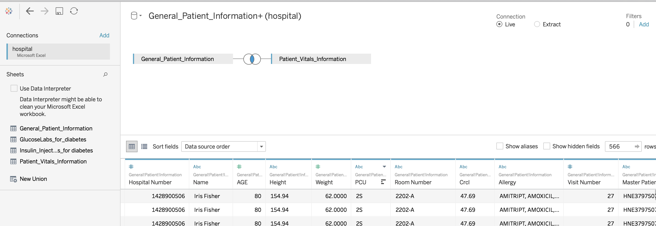

Your solution

Include the graphic and your description of what that graphic means.

*Since this was a measure over time, we went with a line chart with the oxygen saturation measure on the Y-axis and the time of measurement on the X-axis. We used a green/yellow/red coloration to highlight where the measurements were good, approaching bad, and getting dangerous.*

## **Part II: Tableau – Hospital Example Blood Pressure**

Blood Pressure is the measurement of the force of blood pushing against the artery walls. There are two numbers recorded when blood pressure is taken for a patient: systolic pressure and diastolic pressure. The top number (systolic) measures the pressure inside the artery when the heart pumps blood. The bottom number (diastolic) is a measurement of pressure inside the artery when the heart is at rest (not pumping).

Major increases in blood pressure put a patient at risk for heart failure (heart attack) and stroke. Kidney failure is also a risk with elevated blood pressure readings. Since there are two distinct measurements for blood pressure (systolic and diastolic), there are two separate ranges for assessing how serious a blood pressure result is. Use the information of this site to guide you on risk levels for blood pressure readings:

<http://go.iu.edu/1DG7>

We’d like you to use the background information we’ve provided on Blood Pressure to create a Tableau visualization to assist healthcare professionals in monitoring this vital sign. Please provide a screenshot of your visualization, along with a justification/explanation of your visualization.

Your solution

Include the graphic and your description of what that graphic means.

*For this visualization we plotted Iris’s blood pressure measurements in a scatterplot layout, using the systolic measure as the Y-axis and the diastolic measure for the X-axis. We then defined parameters based on the values that were listed in the source provided above, then we used those parameters to define a calculated value to identify the various Blood Pressure zones (Normal, Elevated, High – Stage 1, High – Stage 2, Critical) and color coded our plots based on those zones. We also highlighted the zones using the Annotate Area feature.*

**Part III: Tableau – Hospital Example Temperature**

Normal core body temperatures are at the exact temperature at which all functions of the human body can operate with optimal efficiency. When a patient’s body temperature rises past the normal accepted levels, it can mean many things. Sometimes, diseases like heart failure and pneumonia can cause a patient’s temperature to rise. On the other end of the spectrum, low body temperatures can be a factor of diabetes, sepsis, kidney failure, or drug/alcohol abuse. Since the body functions perform optimally at normal body temperature (98.6), clinicians need to monitor this vital sign closely for any significant changes up or down, past the accepted levels of normalcy.

Several factors like age for example, can influence the patient’s temperature. Typically, when a patient is between 95 and 99 degrees Fahrenheit, they are in the normal range. If their body temperature dips below 95, but stays above 92, they are considered in a warning stage. This is the stage before hypothermia. Anything below 92 is considered hypothermia. Patient’s suffering from the warning signs of hyperthermia, will be in a range of 99 – 101. Above a 101, and they are critical (too hot) and are in hyperthermia.

We’d like you to use the background information we’ve provided on Temperature to create a Tableau visualization to assist healthcare professionals in monitoring this vital sign. Please provide a screenshot of your visualization, along with a justification/explanation of your visualization.

Your solution

Include the graphic and your description of what that graphic means.

*Again, because we were dealing with measurements over time, we thought a line chart would represent this the best. In this case, we identified “danger” zones with red and blue and marked the critical point with a red line on either side. We also used color coding on the line to highlight where temperatures were approaching either of the zones. (Note: the three women that we had data for all had fairly normal ranges of temperatures, so it was difficult to really show a critical measure).*

**Part IV: Tableau – Hospital Example Diabetes**

Diabetes is a growing problem. The data you have contains patients who are diabetic, or are candidates for diabetes. The largest indicator is the patient’s blood glucose levels. Insulin drugs are what are used to mitigate hyperglycemia in patients. Take a look at the hospital Excel spreadsheet. You will find lab results measuring several patient’s blood glucose labs. You will also find a worksheet with Insulin injections or insulin administrations. How much insulin, and when it’s given, have a great impact on the ability to keep blood glucose levels at an acceptable and stable level. Here are few general guidelines on acceptable ranges for diabetic patients: [**https://www.virginiamason.org/whatarenormalbloodglucoselevels**](https://www.virginiamason.org/whatarenormalbloodglucoselevels)

The best way to tackle this problem is to pick a specific patient based on the hospital number. We recommend using the hospital number as a filter, which allow the end user to quickly move from patient to patient, monitoring their specific levels. Your Tableau visualization should retrieve the glucose levels for the selected patient, and chart them in chronological order based on the PERFORM_DATE. You should also consider somehow incorporating the Insulin administrations, including the date and time and dose (amount of the drug administered), and the overall effect the drug is having at mitigating the hyperglycemia. Refer to the required readings from Session 3 on the use of color, size, and shape in creating visualizations.

We’d like you to use the background information we’ve provided on Diabetes to create a Tableau visualization to give the clinician, the best information possible to manage the patient’s diabetic condition. Please provide a screenshot of your visualization, along with a justification/explanation of your visualization.

**You should use both diabetes worksheets to answer this question.**

Your solution

Include the graphic and your description of what that graphic means.

*With this visualization we wanted to show the relationship between insulin dosage time and glucose levels. Based on the source given above, it appears that there are a number of factors that can affect glucose levels (like mealtimes, etc.), however, we weren’t really privy to the data. Based on the two glucose measurements that were provide as markers for Diabetes and Pre-diabetes, we created parameters and added those to our visualization (though, we know that there’s more to determining those factors).*